Experiment No. 3

**Phase Shift Keying (PSK) Modulation and Demodulation**

Object:

* To study and understand the principle of Phase Shift Keying modulation and demodulation
* To learn how to implement PSK modulation and demodulation using Matlab-Simulink.
* To evaluate the performance of PSK modulation and demodulation over AWAG channel.

Theory:

In digital modulation techniques, a set of basis functions are chosen for a particular modulation scheme. Generally the basis functions are orthogonal to each other. Once the basis functions are chosen, any vector in the signal space can be represented as a linear combination of the basis functions.

Binary Phase Shift Keying (BPSK) only one sinusoid is taken as basis function modulation. Modulation is achieved by varying the phase of the basis function depending on the two possible messages *ml* and *m2*. The two phases are usually separated by π radians and this is the only case we consider; it is sometimes called *phase reversal keying* (PRK) and and the maximum rate of BPSK modulation is 1 bit/symbol. Phase reversal keying corresponds to the two possible transmitter waveforms .The following equation outlines BPSK modulation technique.

$s_{BPSK}(t)=\left\{\begin{matrix}\cos\left(ω_{o}t+θ_{o}\right) =\cos\left(ω_{o}t+θ_{o}\right) ,0≤t≤T_{b}, m_{1} sent \\ \cos\left(ω_{o}t+θ_{o}+π\right)=-\cos\left(ω_{o}t+θ_{o}\right),0≤t≤T_{b}, m_{2} sent\end{matrix}\right.$ (1)

Phase-shift keying (PSK) is the phase modulation process which conveys data by changing (modulating) the phase of a constant frequency reference signal (the carrier wave). The modulation is accomplished by varying the sine and cosine inputs at a precise time. The technology is widely used in both military and commercial communication systems such as **wireless LANs**, **RFID** and **Bluetooth communication**. The 6 and 9 Mbit/s modes use **OFDM modulation** where each sub-carrier is BPSK modulated. The 12 and 18 Mbit/s modes use **OFDM with QPSK**. PSK communication is possible **in space**, like **satellite to satellite**, e.g. **in atmosphere** such as in **mobile telephone,** and also **in polarization maintaining optical fibre**. Usually for different mediums different wavelengths of the electromagnetic waves are used.

**PSK Modulation**

In digital communication, the modulating wave consists of binary (2-level) or an M-array (M-level) encoded version of data. The simplest PSK is binary PSK (BPSK). An M-array PSK modulated signal can be expressed as:

$X_{PSK}\left(t\right)=A\sin\left(ω_{c}t+2πi/M\right) i=1,2……M$ (1)

Where the amplitude *A* is arbitrary constant, *ωc* is the angular frequencies and *θi* the phase has M possible values.

If the system uses a binary PSK modulation **2-PSK modulation**, M=2 (A1= and A2=).

The condition of BPSK is

$ω_{c}≫\frac{2π}{T_{b}} , where T_{b} is binary message rate$ (2)

The BFSK transmitted signal is equivalent to a double sideband suppressed-carrier amplitude-modulated waveform (DSB-SC) where the information signal is a digital waveform with polar format. The power spectrum of such a signal is comprised of scaled translations of the message's power spectrum to frequencies ± ωo.

Then, the Bandwidth between first nulls about the carrier is 2Wb.

${PSD}_{BPSK}=\frac{E_{b}}{2}\left[{\left(\frac{sin π\left(f-f_{c}\right)T_{b}}{π(f-f_{c})T_{b}}\right)}^{2}+{\left(\frac{sin π\left(f+f_{c}\right)T_{b}}{π(f+f_{c})T_{b}}\right)}^{2}\right]$ (3)

The BPSK modulation is the most robust of all the PSKs since it takes serious distortion to make the demodulator reach an incorrect decision. It is, however only able to modulate at 1 bit/symbol (as seen in the figure) and is so suitable for high data-rate applications when bandwidth is limited. To Sum, the characteristics of BPSK are:

* One bit forms a symbol
* Two possible symbols.
* Minimum bandwidth is twice of fb.
* Symbol duration = Tb.
* The carrier frequency fc must so larger than the bit message rate (frequency) fb.
* PSK is not susceptible to the noise degradations that affects ASK, or to the bandwidth limitations of FSK. PSK is, however, limited by the ability of the equipment to distinguish small differences in phase. This factor limits its potential transmission bit rate.
* All the information-bearing data is in the signal’s phase.
* Simple to implement, but inefficient use of bandwidth.
* Binary PSK is a very robust modulation technique that is used extensively in satellite digital communications.

Figure 1 shows Binary PSK modulation waveforms. Figure 2 shows the structure of binary FSK modulator.

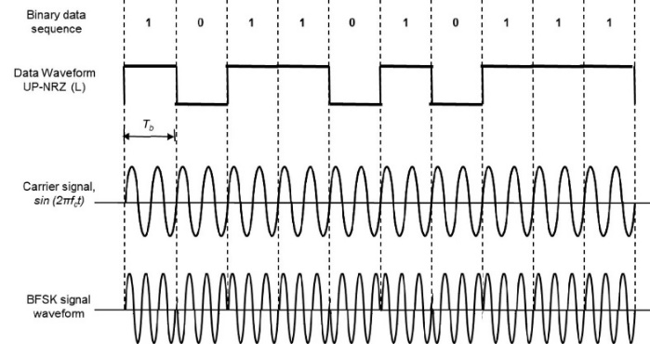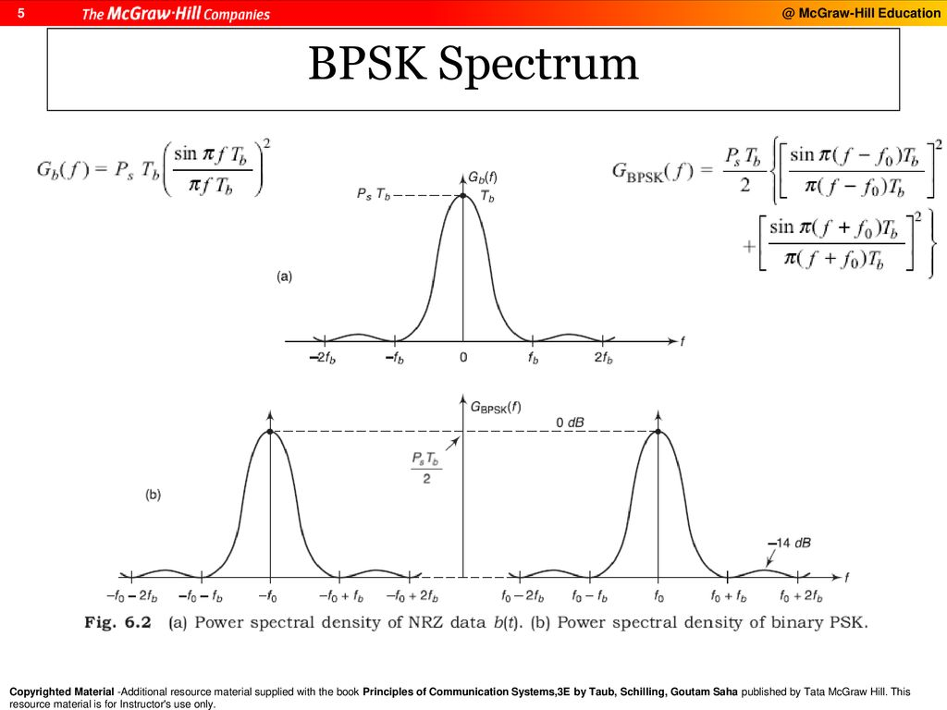

Figure 1 BPSK modulation waveforms and their frequency domains

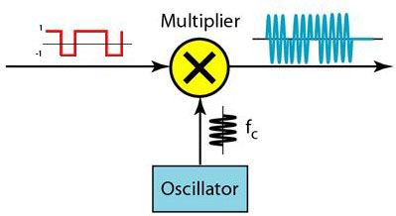

Figure 2 Structure of PSK modulator

**BPSK Demodulation**

The method of demodulation is an important factor in determining the selection of a modulation scheme. There are many types of PSK demodulation which all are distinguished by the need to provide knowledge of the phase of the carrier. Demodulation of a BPSK signal can be considered a two-stage process.

1. translation back to baseband, with recovery of the bandlimited message waveform. Translation back to baseband requires a local, synchronized carrier.
2. regeneration from the bandlimited waveform back to the binary message bit stream.

This Coherent (Synchronous) BPSK Demodulation scheme needs to realize the carrier phase. Coherent demodulation requires less complex circuitry, and has better performance and more effective as against the noise effect. Coherent demodulation System multiplies the BPSK signal by the locally regenerated (replica) carrier with keeping on realization of the phase of the replica carrier signal, termed local oscillator, ‘locked’ to the carrier. The operation of keeping the phase of the replica carrier is difficult to be achieved. In general, Oscillators are sensitive to temperature, noise, and will gradually drift in frequency and phase. Figure 3 shows a block diagram of coherent BPSK demodulator and each stage’s output waveforms.

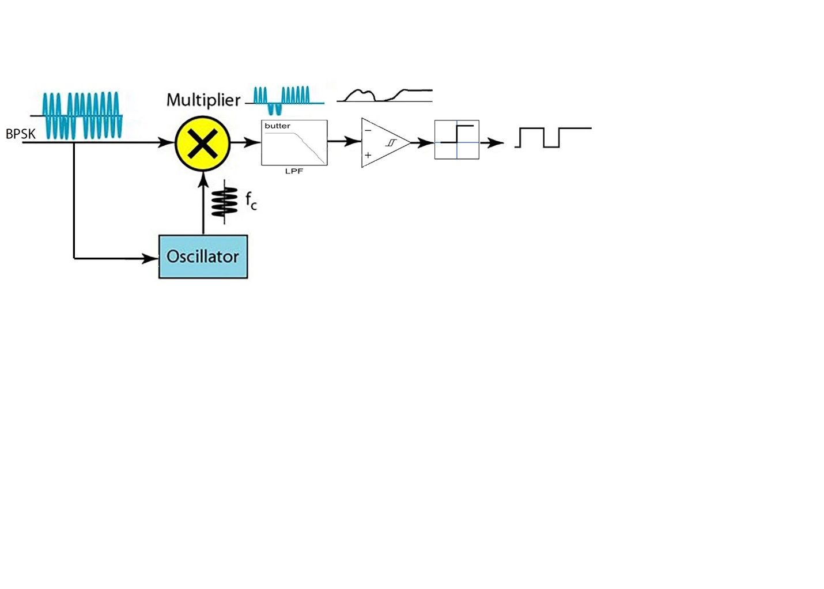

(a)

Figure 3 Binary PSK Coherent Demodulator

**Procedure**

**Part A: Simple BPSK Modulator and Coherent Demodulator**

1. Implement the BPSK modulator and demodulator shown in Figure 4.
2. Set the parameters of all the Sinewave signal generators where waveform is sine with the amplitude 1 V and frequency 4 *2*π rad/sec.
3. To encode the message *m(t)to* generate NRZ, we use Uniform Random Generator with the minimum and maximum value are -1 and 1 respectively and Sign function.
4. Set the parameters of the Analog Filter Design as follows:

**Design method**: Butterworth, **Filter type**: Lowpass, **Filter order**: 8, **Passband edge frequency(rad/sec):** 5*2*π

1. Plot the signals in each scope.
2. What happened when you changed the cutoff (**Passband edge) frequency** to 15*2*π?



Figure 4 Simple BPSK Modulator and Coherent Demodulator

**Part B: Realistic BPSK modulator and Coherent demodulator**

1. Implement the Realistic Coherent BPSK modulator and demodulator shown in Figure 5.

1. Repeat the setting of the parameters of the components as shown in Part A.
2. Set the parameters of AWAG channel as follows:

**Input processing**: Columns as channels, **Initial seed**: 67 (or any number)

**Mode**: Signal to noise ratio (SNR), **SNR (dB)**:30, **Input signal power (watts)**:1

1. Set the parameters of Analog Filter Design (Mod) as follows:

**Design method**: Butterworth, **Filter type**: Lowpass, **Filter order**: 8, **Passband edge frequency(rad/sec):** 4*2*π

Notice: 1 **Radian** per **second** is comparative to 1/2π **Hertz**

1. Set the parameters of Rate Transition with **Initial condition** 0 and Output port sample time 0.00001.
2. In Spectrum Analyzer, Change the RBW (Hz) in Spectrum settings by 100, the dialogue box is found in View.
3. Plot the signals in each scope.
4.  What happened when you changed **Lowpass cutoff frequency** of the channel to 10*2*π?

Figure 5 Realistic BBSK Modulator and Coherent Demodulator

**Discussion**

1. From the result, explain the effect of AWAG channel on BPSK signal when the lowpass filter cutoff frequency was changed.
2. What are the maximum rate and bandwidth of BPSK modulation?
3. What is the value of carrier frequency fc compared to bit message rate fb?
4. Why PSK is considered better than ASK and FSK, what is the thing limits the PSK?
5. What are the applications of PSK?
6. Why the BFSK transmitted signal is equivalent to a double sideband suppressed-carrier amplitude-modulated waveform (DSB-SC), Explain that with figure and formula.